01.Area chart:
1.Open Tableau and connect to your dataset.
2.Drag Order Date to the Columns shelf and change it to Month.
3.Drag Quantity to the Rows shelf.
4.In the Marks card, change the mark type to Area.
5.Drag Ship Mode to Color on the Marks card.
6.Ensure the analysis is displayed as a stacked area chart (Analysis → Stack Marks → On).
7.Format the chart title, colors, and labels as needed.
Output:
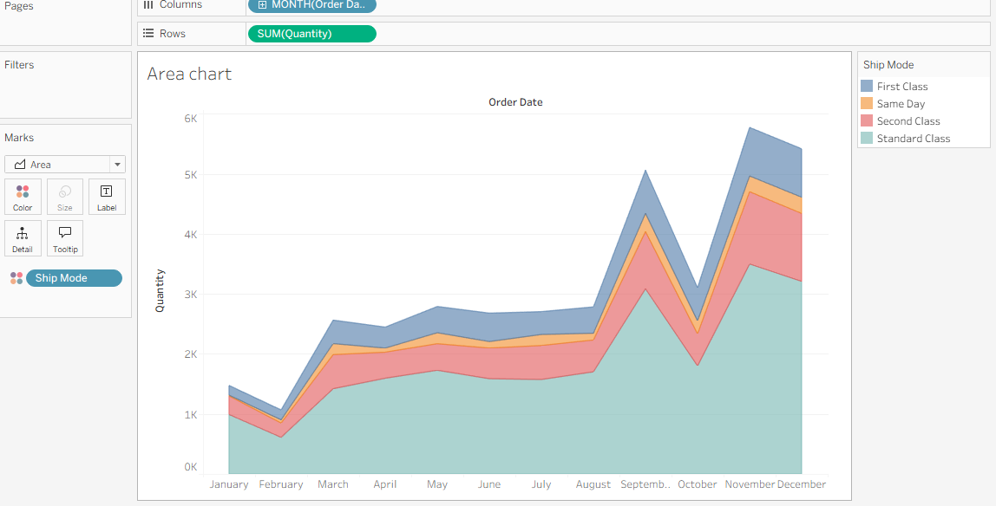

02.Bar chart:
1.Connect to the dataset in Tableau.
2.Drag Region to the Rows shelf.
3.Drag Sales to the Rows shelf (or Columns for a horizontal bar chart).
4.Set the Marks type to Bar.
5.Drag Ship Mode to Color on the Marks card.
6.Drag Region to Filters and select West.
7.Format the title, colors, and labels as needed.
Out put:
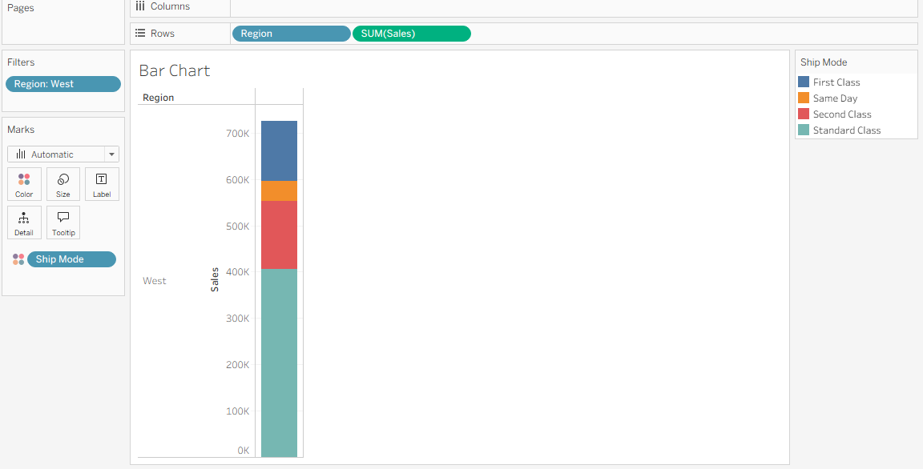

03.Box plot:
1.Connect to the dataset in Tableau.
2.Drag Discount to the Columns shelf.
3.Drag Segment and then Region to the Rows shelf.
4.Open Show Me and select Box-and-Whisker Plot.
5.Ensure Discount is used as the measure for the distribution.
6.Tableau automatically creates the box plot for each Segment–Region combination.
7.Format the chart title, axis, and tooltips as needed.
Out put: 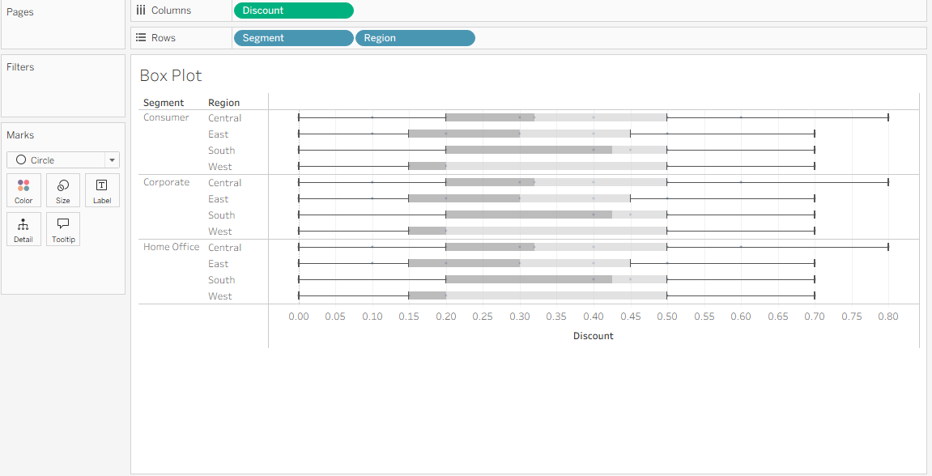

04.Gantt chart :
- Create the calculated field
  - Go to Analysis → Create Calculated Field.
  - Create a field named OrderUntilShip:
  - DATEDIFF('day', [Order Date], [Ship Date])
- Set up the columns
  - Drag Order Date to the Columns shelf.
  - Change it to Week (WEEK(Order Date)).
- Set up the rows
  - Drag Sub-Category to the Rows shelf.
  - Drag Ship Mode next to it on the Rows shelf.
- Change the mark type
  - In the Marks card, select Gantt Bar from the drop-down menu.
- Define the bar size
  - Drag OrderUntilShip to the Size shelf.
  - Use AVG(OrderUntilShip) if needed.
- Add colors
  - Drag Ship Mode to the Color shelf to differentiate each shipping method.

Out put:.

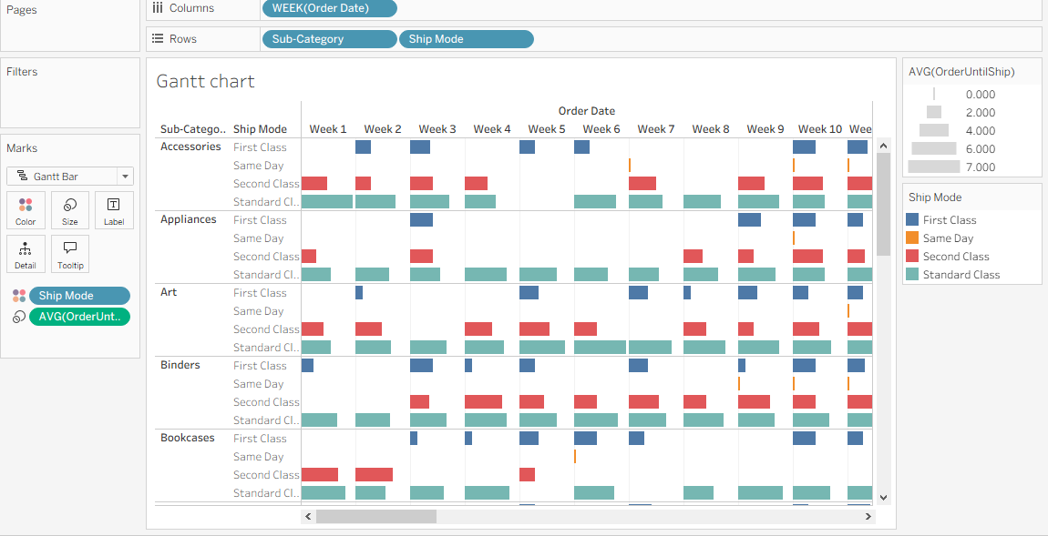

05.Heat Map:
- Place dimensions on shelves
  - Drag Segment to the Columns shelf.
  - Drag Region and Sub-Category to the Rows shelf.
- Select the mark type
  - On the Marks card, change the mark type to Square.
- Add color encoding
  - Drag Profit to the Color shelf.
- Add size encoding
  - Drag Sales to the Size shelf.
- Adjust the color palette
  - Click Color → Edit Colors and choose a diverging palette to highlight positive and negative profits.
- Format the visualization
  - Increase the Size slider for better visibility and add a title such as “Heat Map.

Out put: 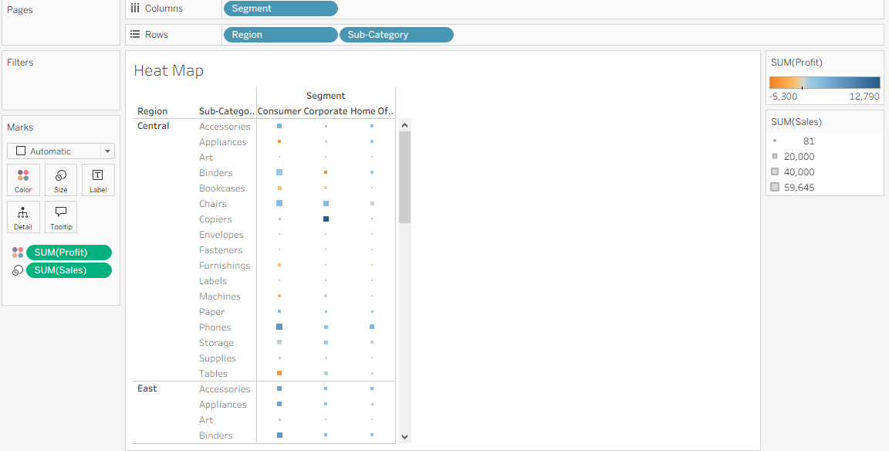

06.Histogram:
- Create a bin
  - Right-click Quantity in the Data pane → Create → Bins.
  - Keep the default bin size or set the desired size.
- Set up the axes
  - Drag Quantity (bin) → Columns.
  - Drag Quantity → Rows and change its aggregation to Count (CNT).
- Choose the chart type
  - Set the Marks type to Bar (or use Show Me → Histogram).
- Add segmentation
  - Drag Segment → Color to create stacked bars by segment.
- Show labels and format
  - Drag CNT(Quantity) → Label and adjust bar size, colors, and title as needed.

Out put:
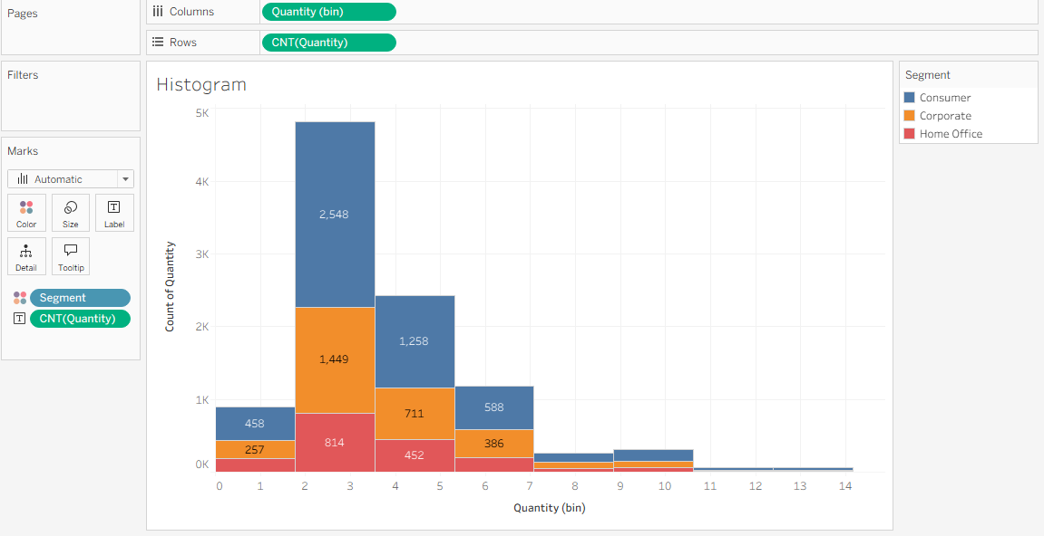

07.Line chart:
- Set up the view
  - Drag Ship Date → Columns and change it to Month (Continuous).
  - Drag Measure Values → Rows.
- Select measures
  - Drag Profit and Sales into the Measure Values card.
  - Drag Measure Names → Filters and keep only Profit and Sales.
- Differentiate the lines
  - Drag Measure Names → Color to create separate lines for each measure.
- Choose the chart type
  - Set the Marks type to Line.
- Add forecasting
  - Open the Analytics pane and drag Forecast onto the view.
  - Adjust forecast options if needed (Forecast → Forecast Options).

Out put:.

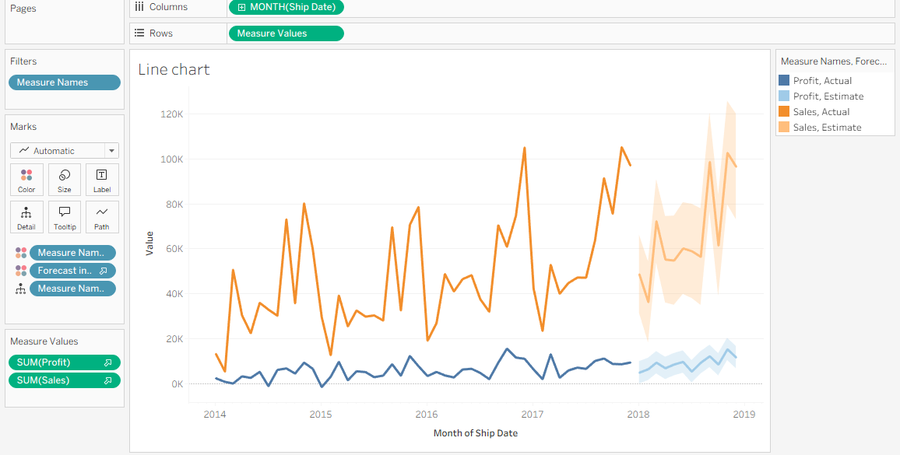

08.Packed Bubbles:
- Choose the chart type
  - Open Show Me and select Packed Bubbles.
- Set the bubble size
  - Drag Sales → Size.
- Define the bubbles
  - Drag Category and Region → Detail to create one bubble for each category–region combination.
- Apply color
  - Drag Profit → Color to show profitability with a color gradient.
- Add labels
  - Drag Category and Region → Label to display names inside each bubble.
- Format the view
  - Adjust the Size slider and edit colors or labels for better readability.

Out put:

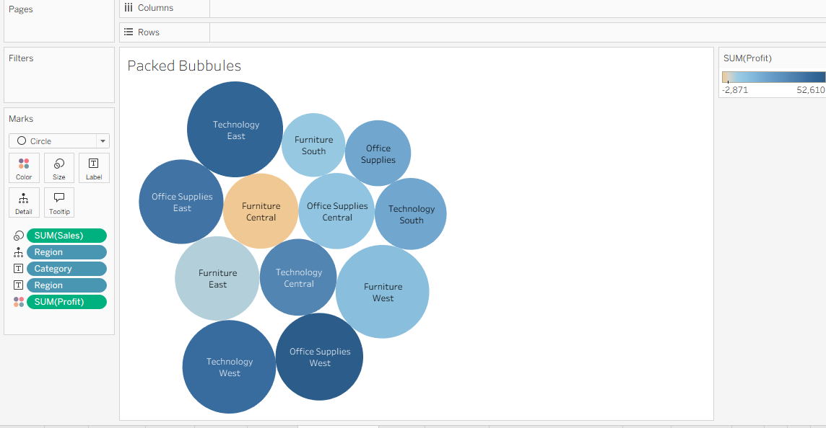

09. Pie chart:
- Choose the chart type
  - On the Marks card, select Pie (or use Show Me → Pie Chart).
- Define the slices
  - Drag Category → Color.
- Set the slice angle
  - Drag Profit → Angle.
- Adjust the pie size
  - Drag Profit → Size and increase the size slider as needed.
- Add labels
  - Drag Category → Label to display category names on each slice.
- Format the chart
  - Edit colors, show labels clearly, and fit the view for better readability.

Out put:
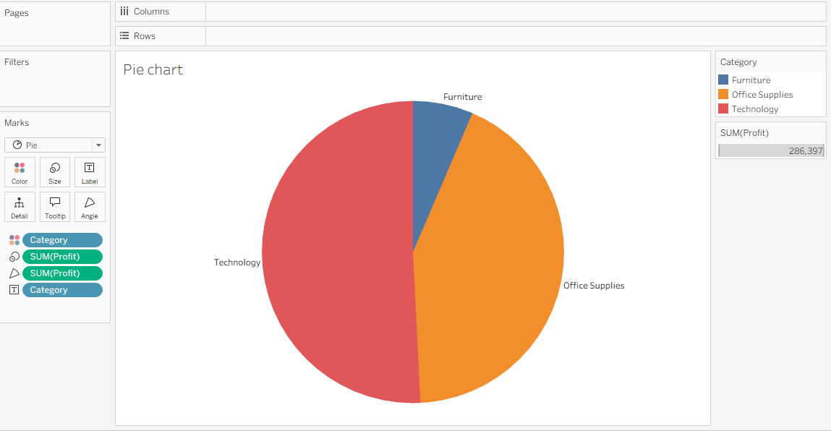

10.Scatter Plot:
- Set up the axes
  - Drag Sales → Columns.
  - Drag Profit → Rows.
- Create the data points
  - Drag Region → Detail to display one mark for each region.
- Differentiate categories
  - Drag Category → Color.
- Choose the chart type
  - Set the Marks type to Circle (or use Show Me → Scatter Plot).
- Add trend lines
  - Open the Analytics pane and drag Trend Line → Linear onto the view.

Out put:
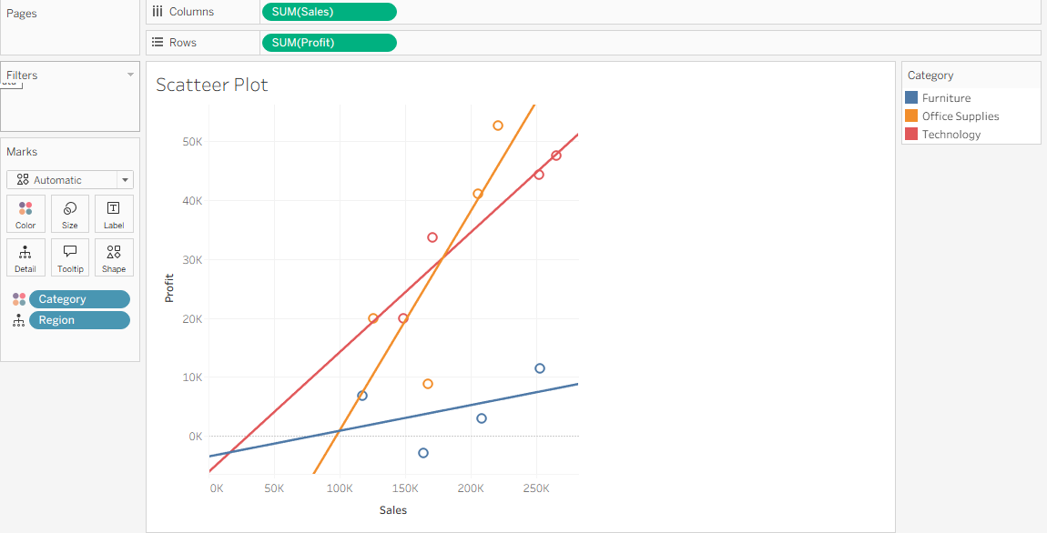

11.Text Table With Percentages:

1. *Right-click `SUM(Sales)`* in the Marks card > Duplicate
2. *Drag the duplicate* `SUM(Sales)` onto the Text mark
3. *Right-click the 2nd `SUM(Sales)`* in Marks > Quick Table Calculation > Percent of Total
4. *Right-click it again* > Compute Using > Table (Across)
5. *Click the 2nd `SUM(Sales)`* pill > Format > Numbers > Percentage with 0 decimals
6. *Edit Label* on Text mark to arrange: `<SUM(Sales)> (<SUM(Sales)2>)`

Out put:

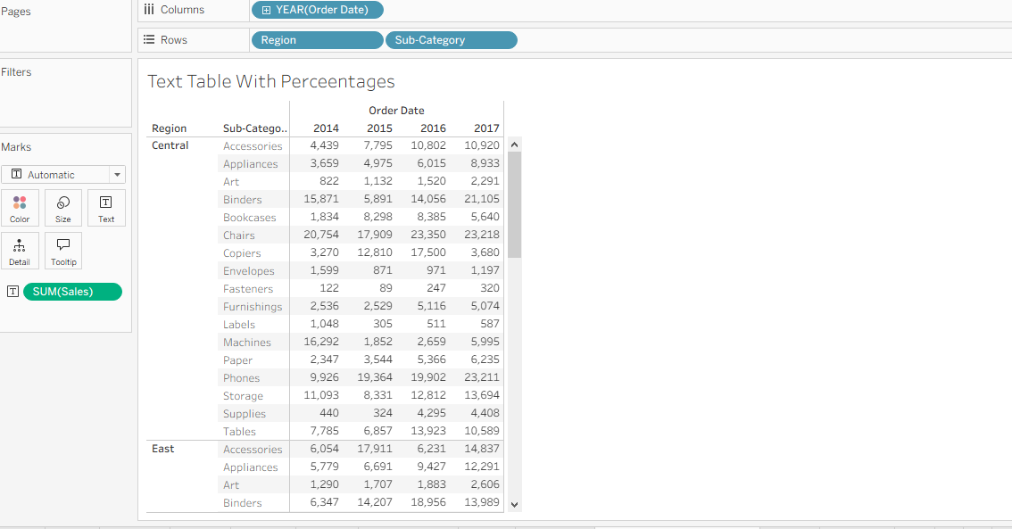

12.Tree Map:
1. *Set Mark type* to `Square` in the Marks card dropdown
2. *Drag `Sub-Category`* to Label
3. *Drag `SUM(Sales)`* to Size
4. *Drag `SUM(Profit)`* to Color
5. *Right-click `SUM(Profit)`* on Color > Edit Colors > Select Orange-Blue Diverging, check "Stepped Color" if needed
6. *Click Color legend* > Edit > Set range to start at negative value to show orange for losses.

Out put:

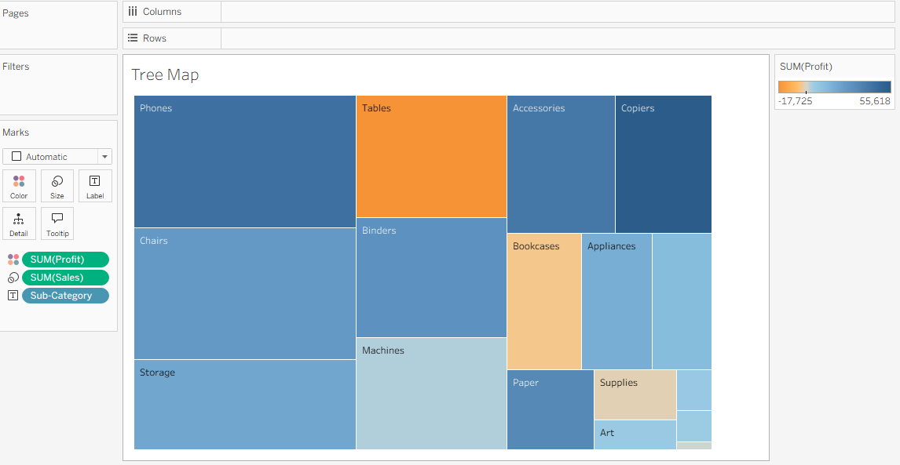

13.Donut Chart:
1. *Create calculated field* `Zero` = `0`
2. *Double-click `Zero`* twice to add `SUM(Zero)` and `SUM(Zero)` to Rows
3. *Set both Marks cards* to Pie, then *Right-click 2nd `SUM(Zero)`* > Dual Axis
4. *On 1st `SUM(Zero)`*: Drag `Region` to Color, `SUM(Sales)` to Angle, `Region` + `SUM(Sales)` to Label
5. *On 2nd `SUM(Zero)`*: Remove all pills, *Set Size* smaller, *Color* to White
6. *Right-click axes* > Edit Axis > Hide both, then *Format* > remove Lines, Gridlines, Zero Lines

Out put: 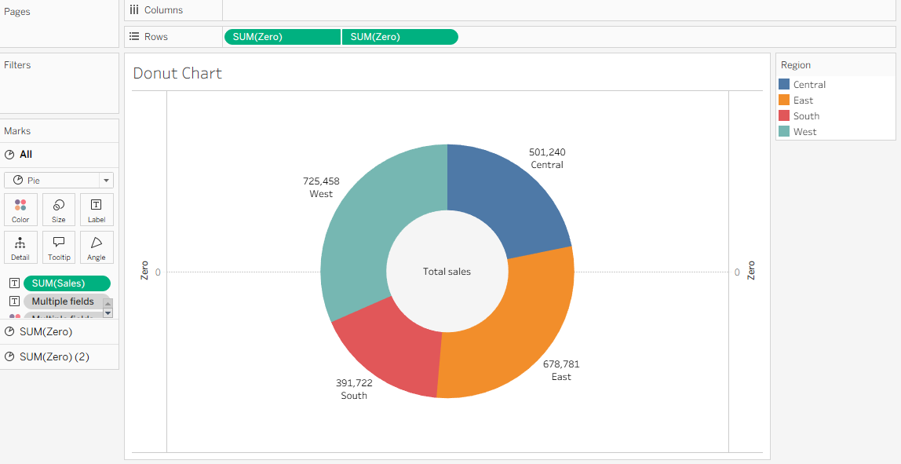

14.Map chart:
1. *Double-click `State`* to auto-generate the map with Longitude/Latitude
2. *Drag `SUM(Sales)`* to Color on the Marks card
3. *Drag `State`* to Label
4. *Drag `SUM(Sales)`* to Label
5. *Click Color* > Edit Colors > Select Purple sequential palette
6. *Drag `SUM(Profit)`* to Tooltip if you want profit on hover.

Out put:
